**Designing The TakeTestFrame**

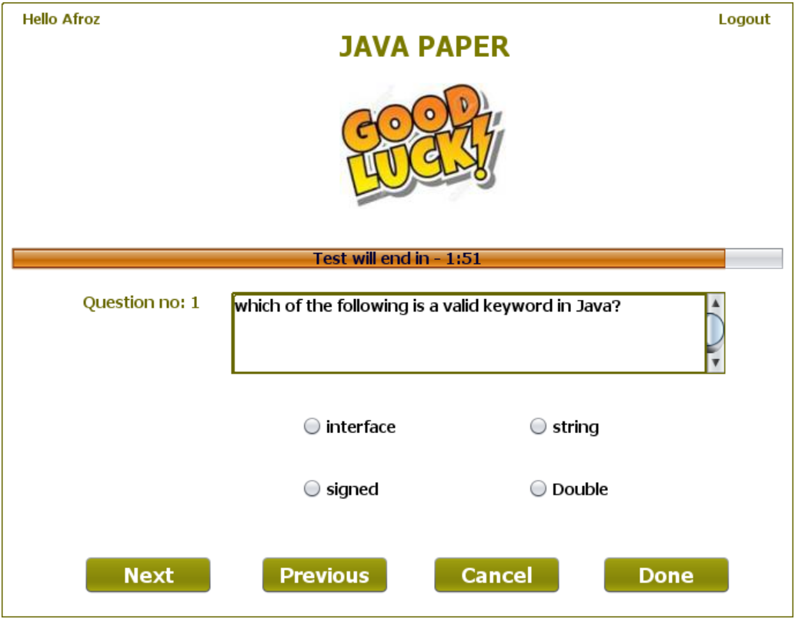

**STEPS TO BE DONE IN** **TakeTestFrame**

In the **TakeTestFrame** we need to do following steps:

1. Handle the constructor for proper initialization of class members

2.In the constructor we also have to **load** the questions from the Database and **display** the first question as well as it's options

3. Write code for the "**Next**" Button. When this button is clicked it should:

**a. Create an Answer POJO object and initialize it with ExamId,Language,Qno,UserAnswer and CorrectAnswer**

**b. Store or replace the Answer object in the astore i.e. AnswerStore**

**c. Load and show the next question**

5. Write code for the "**Previous**" Button. When this button is clicked it should:

**a. Create an Answer POJO object and initialize it with ExamId,Language,Qno,UserAnswer and CorrectAnswer**

**b. Store or replace the Answer object in the astore i.e. AnswerStore**

**c. Load and show the previous question**

6. Write code for the "**Done**" Button. When this button is clicked it should:

**a. Create an Answer POJO object and initialize it with ExamId,Language,Qno,UserAnswer and CorrectAnswer**

**b. Store or replace the Answer object in the astore i.e. AnswerStore**

**c. Calculate unattempted, right and wrong answers given by the student**

**d.Create an object of Performance POJO, initialize it with exam details,username and user's performance.**

**e. Add Performance POJO to the PERFORMANCE table using PerformanceDAO.**

**f. Open ChoosePaperFrame and dispose current frame.**

7. Write code for the "**Cancel**" Button. When this button is clicked it should:

a**. Dispose the current frame and open the ChoosePaperFrame**

**THE TABLES USED IN TakeTestFrame**

**1. QUESTIONS**

|  |  |  |
| --- | --- | --- |
| **Column Name** | **Data Type** | **Description** |
| **EXAMID** | **Varchar2(10)** | **Contains id of the paper** |
| **QNO** | **Number(5)** | **Represents the Question No.** |
| **QUESTION** | **Varchar2(100)** | **Represents Question Description** |
| **ANSWER1** | **Varchar2(30)** | **Option 1** |
| **ANSWER2** | **Varchar2(30)** | **Option 2** |
| **ANSWER3** | **Varchar2(30)** | **Option 3** |
| **ANSWER4** | **Varchar2(30)** | **Option 4** |
| **CORRECT_ANSWER** | **Varchar2(10)** | **The actual correct answer** |
| **LANGUAGE** | **Varchar2(10)** | **Programming language name** |

**2.PERFORMANCE**

|  |  |  |
| --- | --- | --- |
| **Column Name** | **Data Type** | **Description** |
| **USERID** | **Varchar2(10)** | **Contains Admin Provided User ID** |
| **EXAMID** | **Varchar2(10)** | **Contains id of the paper** |
| **RIGHT** | **Number(4)** | **Number of correct answers** |
| **WRONG** | **Number(4)** | **Number of wrong answers** |
| **UNATTEMPTED** | **Number(5)** | **Number of unattempted questions** |
| **PER** | **Number(5,2)** | **Percentage obtained** |
| **LANGUAGE** | **Varchar2(10)** | **Programming language name** |

**THE POJO CLASSES USED IN TakeTestFrame**

1. The **Answer** POJO

2. The **AnswerStore** POJO

3. The **Question** POJO

4. The **QuestionStore** POJO

5.The **Exam** POJO

6.The **Performance** POJO

1. **The Answer POJO**

**The AnswerStore POJO**

**The Performance POJO**

**THE DAO CLASSES USED IN TakeTestFrame**

1. The **QuestionDAO**

2. The **PerformanceDAO**

**HOW TO LOAD AND SHOW THE QUESTIONS:**

The first step we need to do in the **constructor** of **TakeTestFrame** is to load all the questions from the database and show the first question.

To do this we will take 4 steps:

**a. Create a method called loadQuestions( ) in the TakeTestFrame and from this method we will call the method getQuestionsByExamId( ) of the QuestionDAO whose prototype is:**

***public static ArrayList <Question> getQuestionsByExamId(String examId)throws SQLException***

**b. Store all the Question objects in qstore.**

**c. Create a method called showQuestion( ) and show the first question**

**d. Call both the methods from the constructor.**

**WRITING THE CODE FOR BUTTON Button.png IN TakeTestFrame**

**WRITING THE CODE FOR BUTTON Button.png IN TakeTestFrame**

**WRITING THE CODE FOR BUTTON Button.png IN TakeTestFrame**

**WRITING THE CODE FOR BUTTON Button.png IN TakeTestFrame**